 | Pimpri Chinchwad Education Trust’s  Pimpri Chinchwad College of Engineering  (PCCoE)  (An Autonomous Institute)  Affiliated to Savitribai Phule Pune University(SPPU) ISO 21001:2018 Certified by TUV | 
Course: DevOps Laboratory | Code: BIT26VS01
Name: Amar Vaijinath Chavan | PRN: 124B2F001
Assignment 5: Integrate Jenkins with a Git repository .Configure Jenkins to pull code from GitHub.

Aim: To configure a Jenkins Pipeline that securely pulls source code from a GitHub repository onto a dedicated Worker Node using a Personal Access Token for authentication.

Objectives:
- To generate and utilize GitHub Personal Access Tokens (classic) for secure SCM authentication.
- To implement a Declarative Pipeline to automate the "Checkout" process.
- To verify successful code synchronization on a remote Jenkins Worker Node.

Prerequisites:
- Jenkins Master-Worker architecture.
- GitHub Repository: <express-mysql-app-databoard>(any codebase).
- GitHub Personal Access Token with repo scopes.

Theory:

1. GitHub Personal Access Tokens (PAT)

A PAT serves as a secure alternative to using a standard password for Git authentication. In
professional environments, PATs are preferred because they can be scoped to specific permissions
(like "repo" for full control of private repositories) and have expiration dates for better security
management.

2. Jenkins Declarative Pipeline

Unlike Freestyle jobs, a Pipeline allows the entire build process to be defined as code. Using the
pipeline {} block, we can specify which agent (node) should perform the work and define sequential
stages like "Checkout" and "Verify."

Practical Procedure / Steps:

Step 1: Generate GitHub PAT
- Navigate to GitHub Settings > Developer Settings > Personal access tokens (classic).
- Click Generate new token.
- Note: Jenkins-EC2-Key.
- Scopes: Select repo (Full control of private repositories).
- Click Generate token and copy the resulting key (e.g., ghp_...).

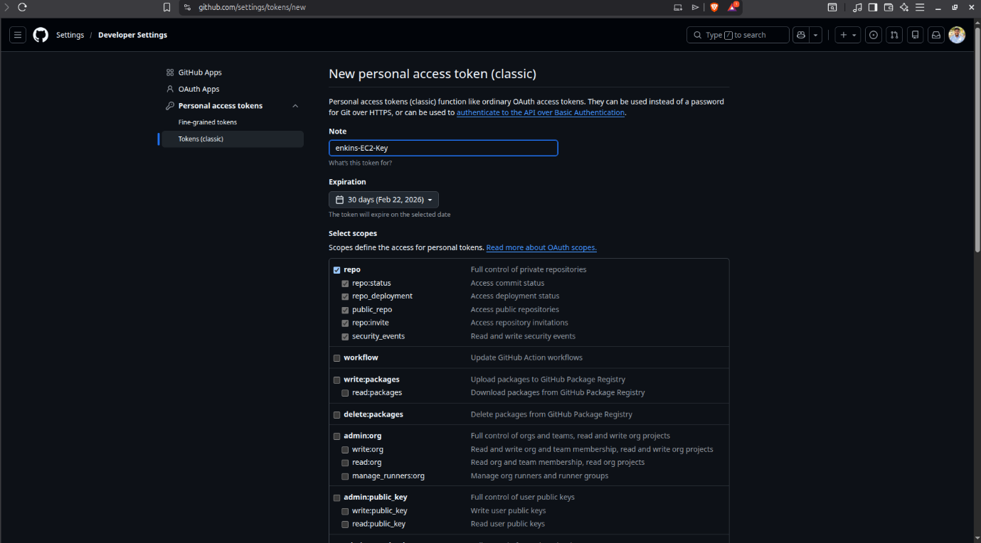
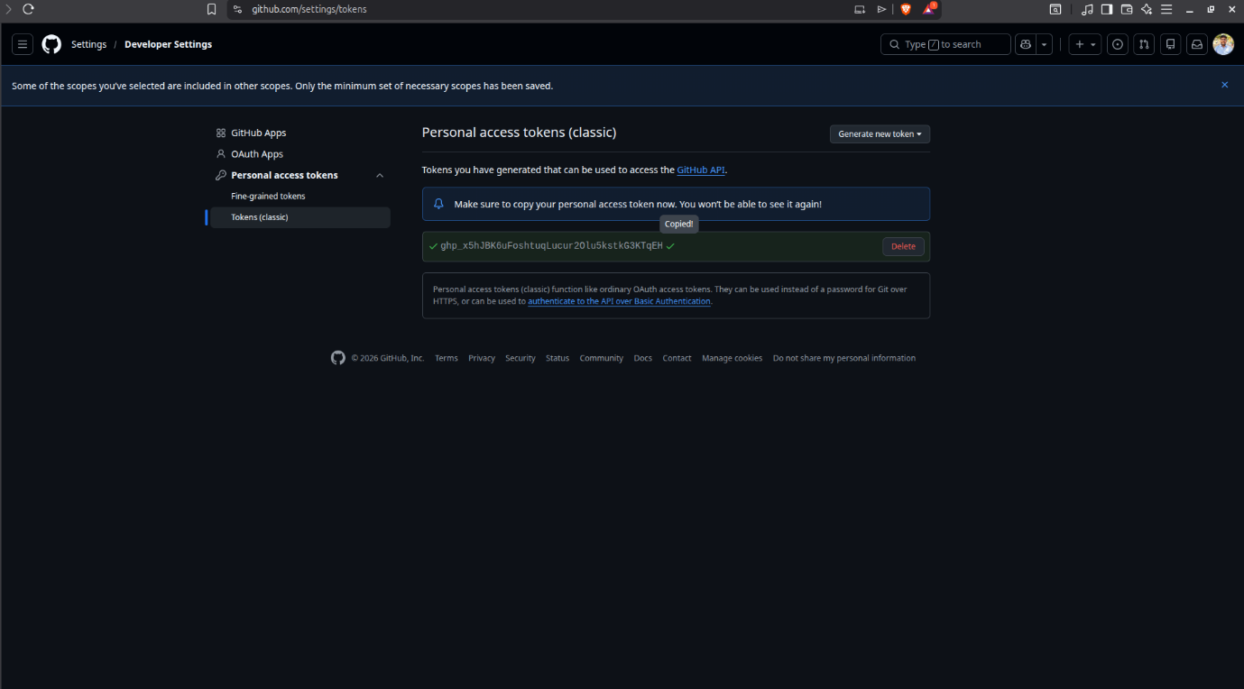

Step 2: Create Jenkins Pipeline Job
- Open Jenkins Dashboard and select New Item.
- Item Name: Assignment-5-Git-Pull.
- Select Pipeline and click OK.

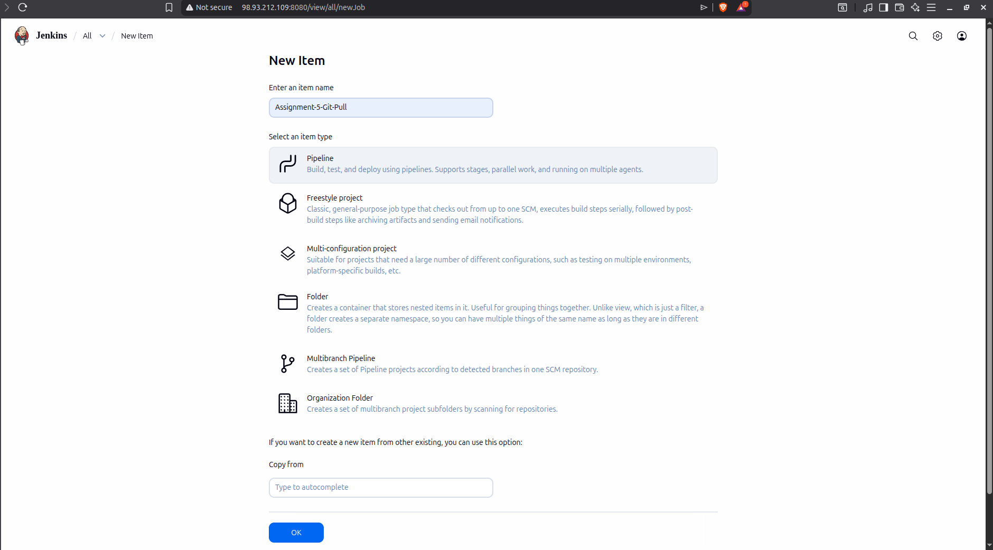

Step 3: Configure Pipeline Script

Navigate to the Pipeline section and enter the following script to target your worker node:

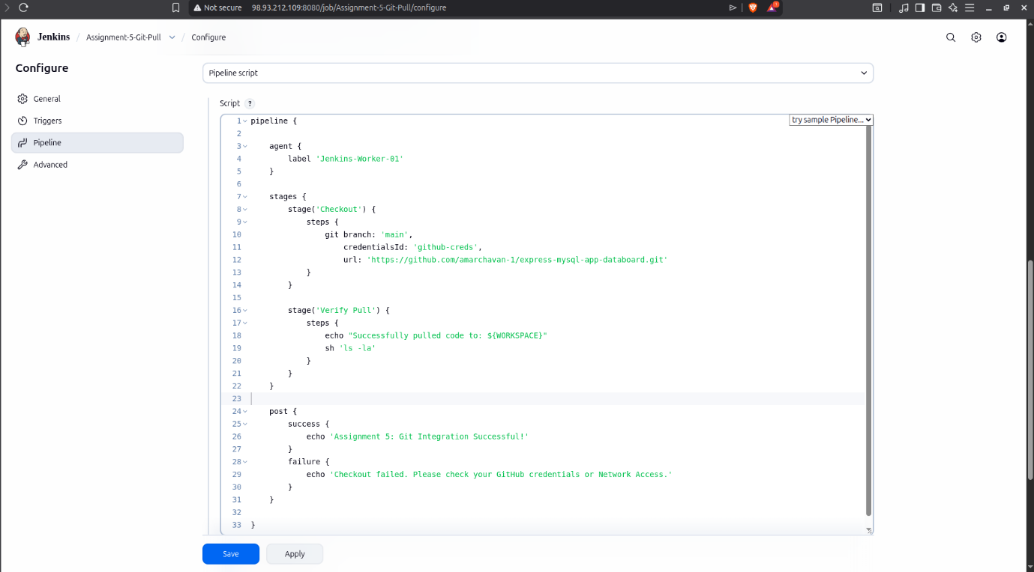

Step 4: Execute and Verify
- Click Build Now.
- Open Console Output to verify the Git clone status.
- Access the Worker Node Terminal and navigate to ~/workspace/Assignment-5-Git-Pull to see the physically cloned files (app.js, package.json, etc.).

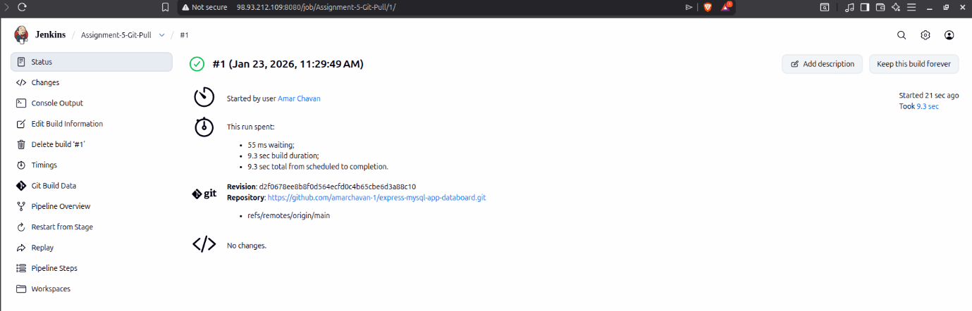

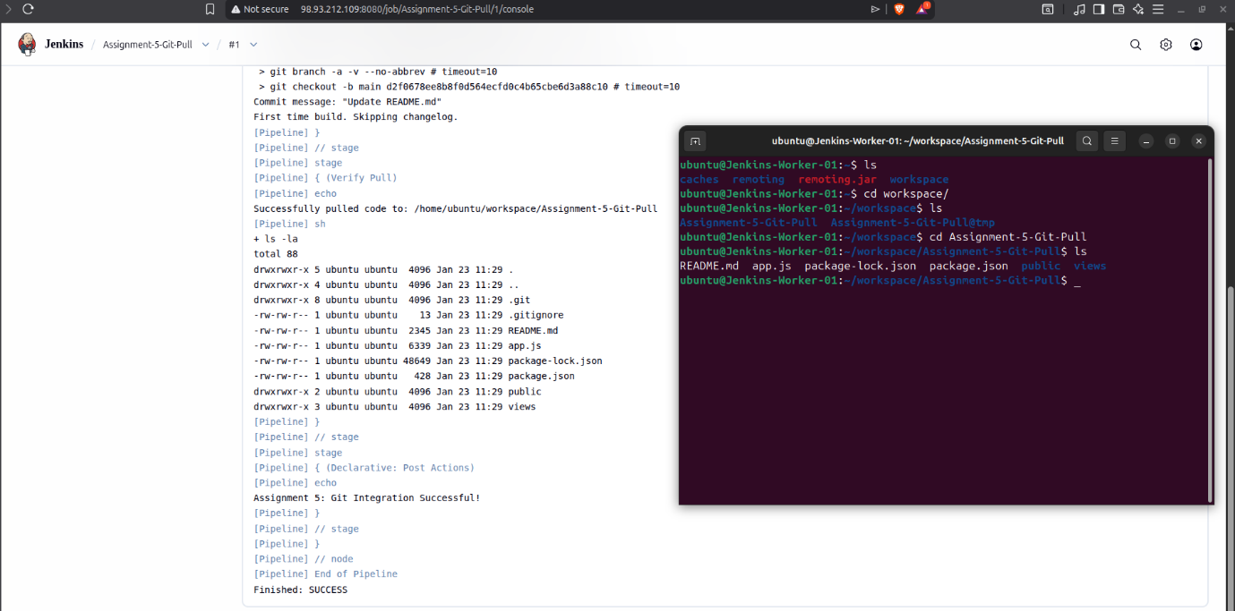

Conclusion
The completion of this assignment demonstrates the critical integration between Jenkins and GitHub, forming the foundation of a secure Continuous Integration workflow. By utilizing a Declarative Pipeline, we successfully automated the source code retrieval process specifically for a remote Worker Node, ensuring the Master remains optimized for orchestration. The use of GitHub Personal Access Tokens (PAT) provided a secure, industry-standard authentication method for accessing the repository. Verifying the cloned files, such as app.js and package.json, directly within the EC2 Worker terminal confirmed the seamless synchronization between the cloud-based version control and our local build environment. This setup effectively simulates a production environment where code is automatically staged for subsequent stages of the DevOps lifecycle.

